Summary
ECOG-ACRIN Cancer Research Group’s Marketing/Clinical Education and Awareness staff will use approved language/images to help increase awareness of EAQ211 and support accrual efforts. The content below may be shared to the ECOG-ACRIN website, affiliated blogs, and social media channels. Links to these channels are included below. Staff at participating EAQ211 sites may also use this content on their own institutions’ social media channels. This plan contains messaging tailored to patients and caregivers.
ECOG-ACRIN Website
https://www.ecog-acrin.org
ECOG-ACRIN Blogs
https://blog-ecog-acrin.org
https://advocacy-ecog-acrin.org
Social Media Channels
Twitter: https://twitter.com/eaonc
Facebook: https://www.facebook.com/eaonc/
LinkedIn: https://www.linkedin.com/company/ecog-acrin-cancer-research-group/
Instagram: https://www.instagram.com/ecog_acrin/
Target Audience(s)
The adolescent and young adult (AYA) and lymphoma cancer communities, including:
- Patients and survivors
- Caregivers
- Advocates
- Research, education, and advocacy organizations (e.g., Cactus Cancer Society, Stupid Cancer, Elephants and Tea, Leukemia & Lymphoma Society, Lymphoma Research Foundation)
Privacy/Confidentiality Considerations
ECOG-ACRIN will make every possible effort to protect privacy and confidentiality by:
- Keeping social media post content general in nature and avoiding any specifics related to the trial or patients on the trial
- Refraining from direct engagement with individuals about their eligibility for trials
  - Instead, individuals will be directed to consult with their physician and/or the NCI’s Cancer Information Service
- Monitoring posts daily for inappropriate responses/interactions and flagging or removing as needed
General/Website Messaging
EAQ211 Study
Evaluating the Impact of Social and Genetic Factors on Outcomes in Adolescent and Young Adult (AYA) Cancer Survivors
Why consider participating in this study?
- Survivors of cancer diagnosed in adolescence or young adulthood (ages 18-39) have a higher risk of multiple health problems, due to having unique experiences that have effects on their overall health, mental health, and quality of life.
- EAQ211 is being done to answer the following questions:
  - How do life circumstances and mental health affect human gene activity and health outcomes for AYA lymphoma survivors?
  - Do differences in life circumstances or mental health contribute to differences in gene activity and health outcomes for some AYAs after completion of lymphoma cancer treatment?
- Furthermore, this study aims to find out how to improve care for AYAs diagnosed with and treated for lymphoma. EAQ211 may inform future research and care by identifying who may be at increased risk for long-term late effects and medical problems associated with cancer treatment.
What does this study involve?
- If you choose to participate in EAQ211, you will fill out an initial survey that asks a variety of questions about your health, environment, and quality of life. You will also provide a blood sample, either collected at your clinic or at an alternate location/time of your choice via mobile phlebotomy.
  - After that, you will complete an online survey and provide a blood sample every 6 months for 24 months (5 surveys and 5 blood draws total). The surveys will each take about 20 minutes to complete.

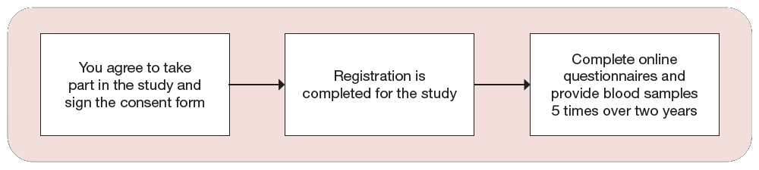
Who will take part in this study?
- Approximately 2,000 disease-free survivors of Hodgkin and Non-Hodgkin lymphoma will participate in EAQ211. You must be 18–39 years of age and must have completed treatment in the past 12 months.
- Please note, you can decide to stop participating in the study at any time.
What are the costs of taking part in this study?
- You may receive up to $100 in gift cards for participating in this study. You will receive a $20 gift card of your choosing after each time that you complete an online survey and provide a blood sample.
- You and/or your insurance provider will not have to pay for the blood collections or the research tests.
- Depending on your personal cell phone plan, there may be added costs related to receiving text notifications from the study team that will remind you when surveys are available to be completed. Also, there may be added costs to your cellphone bill if you complete the online surveys using a personal smartphone or tablet without Wi-Fi.
If you would like to know more
- About the EAQ211 study, talk with your doctor, or:
  - Visit www.ecog-acrin.org and search EAQ211, then select the link to the EAQ211 Home Page.
    - For information about locations where the study is available, scroll down the page to Locations and Contacts and click the + sign.
  - Visit www.aftercancergenomics.org or follow @cancergenomics_ on social media.
  - Call the NCI Cancer Information Service at 1-800-4-CANCER (1-800-422-6237).
- About clinical trials:
  - General cancer information: visit the NCI website at www.cancer.gov
  - Insurance coverage: visit www.cancer.gov/clinicaltrials/learningabout/payingfor
- About ECOG-ACRIN:
  - Visit www.ecog-acrin.org
  - For a list of patient resources and links to patient advocacy groups, visit https://ecog-acrin.org/patients/resources

Social Media Messaging
Facebook/LinkedIn | Twitter
The EAQ211 clinical study is evaluating the impact of social and genetic factors on outcomes in adolescent & young adult (#AYA) #cancer survivors. Learn more: https://bit.ly/eaq211-study #AYACancer #AYACSM | The EAQ211/@cancergenomics_ clinical study is evaluating the impact of social and genetic factors on outcomes in adolescent & young adult (#AYA) #cancer survivors. Learn more: https://bit.ly/eaq211-study #AYACancer #AYACSM
Are you a teen or young adult #lymphoma survivor that has finished treatment? If so, you may be eligible to participate in the EAQ211 study that could make a positive impact on the #AYA #cancer community. Learn more: https://bit.ly/eaq211-study #AYACancer #AYACSM | Are you a teen or young adult #lymphoma survivor that has finished treatment? If so, you may be eligible to participate in the @cancergenomics_ study that could make a positive impact on the #AYA #cancer community. Learn more: https://bit.ly/eaq211-study #AYACancer #AYACSM
#ClinicalTrial EAQ211/@cancergenomics_, led by Dr. Brad Zebrack of @UMRogelCancerCenter & @universityofmichigan.schoolofsocialwork, aims to improve care for #AYAs diagnosed with and treated for #lymphoma. Learn more: https://bit.ly/eaq211-study #AYACancer #AYACSM | #ClinicalTrial EAQ211/@cancergenomics_, led by @BradZebrack of @UMRogelCancer & @UMSocialWork, aims to improve care for #AYAs diagnosed with and treated for #lymphoma. Learn more: https://bit.ly/eaq211-study #AYACancer #AYACSM
Hashtags: #AYA #cancer #AYACancer #AYACSM
Images
