Summary
ECOG-ACRIN Cancer Research Group’s Marketing/Clinical Education and Awareness staff will use approved language/images to help increase awareness of EAY191/ComboMATCH and support accrual efforts. The content below may be shared to the ECOG-ACRIN website, affiliated blogs, and social media channels. Links to these channels are included below. Staff at participating ComboMATCH sites may also use this content on their own institutions’ social media channels. This plan contains messaging tailored to patients and caregivers.
ECOG-ACRIN Website
https://www.ecog-acrin.org
ECOG-ACRIN Blogs
https://blog-ecog-acrin.org
https://advocacy-ecog-acrin.org
Social Media Channels
Twitter: https://twitter.com/eaonc
Facebook: https://www.facebook.com/eaonc/
LinkedIn: https://www.linkedin.com/company/ecog-acrin-cancer-research-group/
Instagram: https://www.instagram.com/ecog_acrin/
Target Audience(s)
The cancer community, including:
- Patients and survivors
- Caregivers
- Advocates
- Research, education, and advocacy organizations
Privacy/Confidentiality Considerations
ECOG-ACRIN will make every possible effort to protect privacy and confidentiality by:
- Keeping social media post content general in nature and avoiding any specifics related to the trial or patients on the trial
- Refraining from direct engagement with individuals about their eligibility for trials
  - Instead, individuals will be directed to consult with their physician and/or the NCI’s Cancer Information Service
- Monitoring posts daily for inappropriate responses/interactions and flagging or removing as needed
General/Website Messaging
ComboMATCH/EAY191 Study
Registration for Treatment Assignment Based on Genetic Testing

Why consider participating in this study?
- Research studies are an important way to test the effectiveness of new therapies and approaches for treating cancer.
- The usual approach (i.e., the standard treatment most people receive after a diagnosis of cancer) involves surgery, radiation, and/or chemotherapy.
- ComboMATCH/EAY191 will help determine if you are eligible to participate in a trial testing new combinations of anti-cancer drugs, based on the characteristics of your tumor. The drug combinations have shown evidence that they may be more effective than single-drug therapy in treating some cancers.
  - If you participate in ComboMATCH, you could be matched to a specific treatment trial based on the genetic makeup of your tumor. If you are matched, you will be offered the treatment prescribed in that study, which may involve one or more of the standard treatments.
  - ComboMATCH is being done to help see whether a combination of drugs based on your tumor’s genetic characteristics will be a better treatment than the usual approach.

What does this study involve?
- All ComboMATCH participants are required to have, or previously have had, a sample of their tumor tested by a ComboMATCH-designated laboratory, and the results must show that you are able to join the study.
- If your tumor has a genetic change or mutation that is targeted by one or more of the drugs used in ComboMATCH, you will be asked to participate in a treatment trial, and a sample of your tumor, if available, will be sent to the ComboMATCH study central laboratory.
  - For patients aged 18 or older: if your tumor can be biopsied with minimal risk and you have matched to a treatment trial, you will need to have a new biopsy prior to starting treatment. If your tumor can’t be biopsied, you must have tissue available from a previous biopsy that can be used for the study.
  - For patients younger than 18 years old, you will be asked if you are willing to:
    - Submit previously biopsied tissue, if available, or
    - Have a new optional biopsy for research purposes, if the biopsy can be performed at minimal risk.
  - These sample results will be compared to the sample results that were provided from the ComboMATCH-designated laboratory.

Who will take part in this study?
- Approximately 2900 people will take part in this study. Participants must have cancer that has spread to nearby tissue or lymph nodes (locally advanced) or to other places in the body (advanced) that has gotten worse after standard treatment; ComboMATCH is also for patients with a type of advanced cancer for which no standard treatment exists.
- You can decide to stop taking part in this study at any time, even after you have enrolled.

What are the costs of taking part in this study?
- You and/or your insurance plan will need to pay for some or all of the costs of medical care you get as part of this study. Please check with your insurance company to find out what they will pay for.
- You will not pay for:
  - the costs of the genetic test performed on the submitted tissue
  - any other research studies done on the submitted tissue samples
  - the cost of shipping the samples to the central lab
- If you are eligible to get study drug(s) on a treatment trial, any costs of being in the study will be discussed along with details of your treatment.

How does ComboMATCH work?

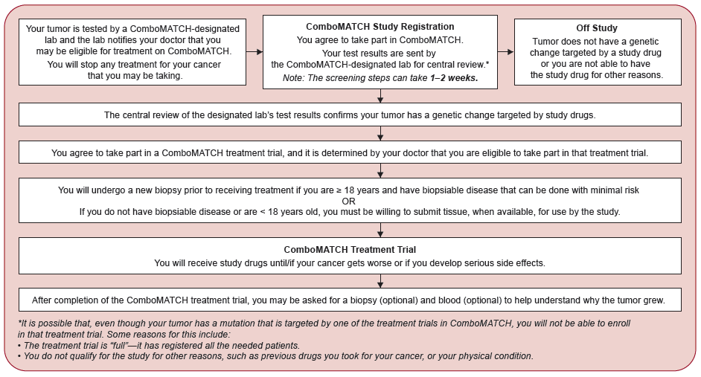

If you would like to know more
- About the ComboMATCH/EAY191 study, talk with your doctor, or:
  - Visit www.ecog-acrin.org and search EAY191, then select the link to EAY191.
    - For information about medical facilities where the study is available, scroll down the page to Locations and Contacts.
    - For a current list of the ComboMATCH treatment trials: visit www.ecog-acrin.org/treatment-trials/
  - Call the NCI Cancer Information Service at 1-800-4-CANCER (1-800-422-6237)
- About clinical trials:
  - General cancer information: visit the NCI website at www.cancer.gov
  - Insurance coverage: visit www.cancer.gov/clinicaltrials/learningabout/payingfor
- About ECOG-ACRIN:
  - Visit www.ecog-acrin.org
  - For a list of patient resources and links to patient advocacy groups, visit www.ecog-acrin.org/patients/resources

Social Media Messaging
Facebook/LinkedIn | Twitter
The #ComboMATCH Study, led by researchers from @StanfordCancer, @MDAndersonNews, @PennCancer, & @NCItreatment, is testing new combinations of anti-#cancer drugs, based on the characteristics of patients’ tumors. Learn more: http://bit.ly/ComboMATCH #PrecisionMedicine | The #ComboMATCH Study, led by researchers from Stanford Cancer Institute, MD Anderson Cancer Center, Penn Medicine - Abramson Cancer Center, & the National Cancer Institute, is testing new combinations of anti-#cancer drugs, based on the characteristics of patients’ tumors. Learn more: http://bit.ly/ComboMATCH #PrecisionMedicine
Do you have advanced #cancer that has become worse following treatment, or advanced cancer for which no standard treatment exists? If so, you may be able to join the #ComboMATCH #PrecisionMedicine study. Learn more: http://bit.ly/ComboMATCH | Do you have advanced #cancer has become worse following treatment, or advanced cancer for which no standard treatment exists? If so, you may be able to join the #ComboMATCH #PrecisionMedicine study. Learn more: http://bit.ly/ComboMATCH
In the #ComboMATCH Study, researchers are testing if genetically-matched drug combinations will be more effective than single drugs for certain patients with #cancer. Learn more: http://bit.ly/ComboMATCH #PrecisionMedicine #ClinicalTrial | In the #ComboMATCH Study, researchers are testing if genetically-matched drug combinations will be more effective than single drugs for certain patients with #cancer. Learn more: http://bit.ly/ComboMATCH #PrecisionMedicine #ClinicalTrial
Hashtags: #ComboMATCH #PrecisionMedicine #PrecisionOncology #ClinicalTrial #genetics #cancer
Images
