Summary
ECOG-ACRIN Cancer Research Group’s Marketing/Clinical Education and Awareness staff will use approved language/images to help increase awareness of EA9171 and support accrual efforts. The content below may be shared to the ECOG-ACRIN website, affiliated blogs, and social media channels. Links to these channels are included below. Staff at participating ECOG-ACRIN sites may also use this content on their own institutions’ marketing/communications channels.
ECOG-ACRIN Website
https://www.ecog-acrin.org
ECOG-ACRIN Blogs
https://blog-ecog-acrin.org
https://advocacy-ecog-acrin.org
Social Media Channels
Twitter: https://twitter.com/eaonc
Facebook: https://www.facebook.com/eaonc/
LinkedIn: https://www.linkedin.com/company/ecog-acrin-cancer-research-group/
YouTube (video only): https://www.youtube.com/channel/UCAC_V1QdqlH2KdHOt7K2IHw
Target Audience(s)
The leukemia/blood cancer community, including:
- Patients and survivors
- Caregivers
- Advocates
- Research, education, and advocacy organizations
Privacy/Confidentiality Considerations
ECOG-ACRIN will make every possible effort to protect privacy and confidentiality by:
- Keeping social media post content general in nature and avoiding any specifics related to the trial or patients on the trial
- Refraining from direct engagement with individuals about their eligibility for trials
  - Instead, individuals will be directed to consult with their physician and/or the NCI’s Cancer Information Service
- Monitoring posts daily for inappropriate responses/interactions and flagging or removing as needed
General/Website Messaging
EA9171/BLAST MRD CML 1 Study
Testing Pembrolizumab with Existing Cancer Therapy in Patients with Evidence of Residual Chronic Myelogenous Leukemia (CML)

Why consider participating in this study?
- Research studies are an important way to test the effectiveness of new drugs for treating CML.
- All study participants will receive the usual treatment for this cancer, which is continuous therapy with tyrosine kinase inhibitors (TKIs) (i.e., imatinib [Gleevec], dasatinib [Sprycel], bosutinib [Bosulif], or nilotinib [Tasigna]). In addition, all participants will also receive the study drug, pembrolizumab (Keytruda), by vein (intravenously).
- The purpose of the EA9171/BLAST MRD CML 1 study is to determine the effects of adding pembrolizumab to the usual treatment.
  - Researchers hope to learn if pembrolizumab will shrink the cancer/prevent it from returning.

What does this study involve?
- All study participants who decide to enroll in this study will be on Arm A and will receive pembrolizumab by vein once every 3 weeks for 18 doses (total duration of 54 weeks). During this time, you will continue to take the TKI you were on prior to joining the study.
- After completing 54 weeks of treatment, a decision regarding your further treatment strategy will be made depending on whether a fusion gene product, called bcr-abl, remains detectable in your blood. This is referred to as minimal residual disease (MRD) testing.
  - If bcr-abl is undetectable (referred to as undetectable MRD, or UMRD), you will stop receiving pembrolizumab and will only continue the TKI.
» If bcr-abl remains undetectable in your blood for a year, then you would stop taking your TKI and your bcr-abl levels will be monitored for 2 years.
» If bcr-abl becomes detectable in your blood again, you will start back on a TKI and will come off the study.
  - If bcr-abl remains detectable (you have minimal residual disease), after the first year in the study, you will continue to Arm B and receive both TKI and pembrolizumab for another year. Then, your bcr-abl levels will be checked.
» If there is no evidence of bcr-abl, you will stop taking your TKI and you will be monitored for an additional 2 years. Or, if you still have detectable bcr-abl in your blood, you will come off the study.
- After you finish your study treatment, your doctor will continue to follow your condition at least every 6 months. You will continue to see your doctor for up to 6 years.
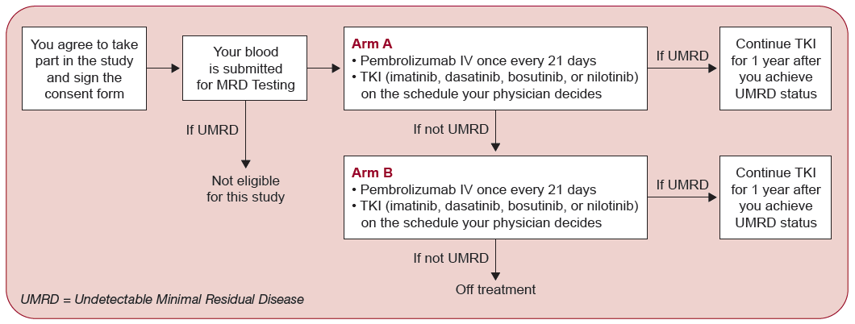

Who will take part in this study?
- There will be about 40 people taking part in EA9171/BLAST MRD CML 1.
- Participants must be at least 18 years old, and must not have had a previous allogeneic transplant, or received prior therapy with an anti-PD-1, anti-PD-L1, or anti-PD-L2 agent.
- Please note, you can decide to stop taking part in this study at any time, even after you have enrolled.

What are the costs of taking part in this study?
- You/your insurance provider will not have to pay for pembrolizumab (including preparation/administration) or scheduled MRD assessments while you take part in EA9171/BLAST MRD CML 1.
- You and/or your insurance plan will need to pay for some or all of the costs of medical care you get as part of this study, just as you would if you were getting the usual care for your cancer. Check with your insurance company to find out what they will pay for.

If you would like to know more
- About the EA9171/BLAST MRD CML 1 study, talk with your doctor, or:
  - Visit www.ecog-acrin.org and search EA9171, then select the link to the EA9171 Home Page.
» If you are seeking information about the locations where the study is available, scroll down the page to Locations and Contacts and click the + sign.
  - Call the NCI Cancer Information Service at 1-800-4-CANCER (1-800-422-6237)
- About clinical trials:
  - General cancer information: visit the NCI website at www.cancer.gov
  - Insurance coverage: visit www.cancer.gov/clinicaltrials/learningabout/payingfor
- About ECOG-ACRIN:
  - Visit www.ecog-acrin.org
  - For a list of patient resources and links to patient advocacy groups, visit https://ecog-acrin.org/patients/resources
Social Media Messaging
Facebook/LinkedIn | Twitter
Dr. Amer Zeidan of @SmilowCancerHospital is leading clinical study EA9171, testing if adding a new drug to the usual treatment for chronic myelogenous leukemia could help patients. Learn more: https://bit.ly/ea9171-study | .@Dr_AmerZeidan of @SmilowCancer & @YaleCancer is leading clinical study EA9171, testing if adding a new drug to the usual treatment for chronic myelogenous #leukemia could help patients. Learn more: https://bit.ly/ea9171-study #CML #leusm
Do you have chronic myelogenous leukemia (CML)? If so, you may be able to participate in this study of a potential new treatment. Learn more: https://bit.ly/ea9171-study | Do you have chronic myelogenous #leukemia (#CML)? If so, you may be able to participate in this study of a potential new treatment. Learn more: https://bit.ly/ea9171-study #leusm #BloodCancer
If you have chronic myelogenous leukemia (CML) you may be eligible to participate in a study that could help advance treatment for future patients. Learn more: https://bit.ly/ea9171-study | If you have chronic myelogenous #leukemia (#CML) you may be eligible to participate in a study that could help advance treatment for future patients. Learn more: https://bit.ly/ea9171-study #CML #leusm
Hashtags: #leukemia #CML #leusm #BloodCancer
