Summary
ECOG-ACRIN Cancer Research Group’s Marketing/Clinical Education and Awareness staff will use approved language/images to help increase awareness of EA8191/INDICATE and support accrual efforts. The content below may be shared to the ECOG-ACRIN website, affiliated blogs, and social media channels. Links to these channels are included below. Staff at sites participating in the EA8191/INDICATE trial may also use this content on their own institutions’ marketing/communications channels.
ECOG-ACRIN Website
https://www.ecog-acrin.org
ECOG-ACRIN Blogs
https://blog-ecog-acrin.org
https://advocacy-ecog-acrin.org
Social Media Channels
Twitter: https://twitter.com/eaonc
Facebook: https://www.facebook.com/eaonc/
LinkedIn: https://www.linkedin.com/company/ecog-acrin-cancer-research-group/
YouTube (video only): https://www.youtube.com/channel/UCAC_V1QdqlH2KdHOt7K2IHw
Target Audience(s)
The Prostate Cancer community, including:
- Patients and survivors
- Caregivers
- Advocates
- Research, education, and advocacy organizations
Privacy/Confidentiality Considerations
ECOG-ACRIN will make every possible effort to protect privacy and confidentiality by:
- Keeping post content general in nature and avoiding any specifics related to the trial or patients on the trial
- Refraining from direct engagement with individuals about their eligibility for trials
  - Instead, individuals will be directed to consult with their physician and/or the NCI’s Cancer Information Service
- Monitoring posts daily for inappropriate responses/interactions and flagging or removing as needed
General/Website Messaging
EA8191/INDICATE
Treating Prostate Cancer That Has Come Back after Surgery with Apalutamide and Targeted Radiation Based on PET Imaging
Why consider participating in this study?
- Research studies are an important way to test the effectiveness of new therapies and approaches for treating prostate cancer.
- In the EA8191/INDICATE study, ALL participants will receive the usual treatment for prostate cancer that recurs after surgery, which is radiation therapy (RT) to the prostate bed and pelvic lymph nodes, combined with short-term (6 months) androgen deprivation therapy (STAD). In addition:
  - Some patients will receive additional PET imaging, depending on the results of their initial PET scan.
  - Some patients will also receive a type of hormone therapy called apalutamide, which is approved by the FDA for treatment of your prostate cancer.
  - Some patients, depending on the results of their initial PET scan, will receive metastasis-directed radiation therapy.
- To decide which of these approaches may be better, doctors will look to see if your cancer shrinks or goes away. They will also look to see if it returns again, and if so how much time passes after your treatment before it returns.
What does this study involve?
- If your PET scan does not show evidence that your cancer has spread outside of the pelvis, you will be assigned by chance (randomized) to Group 1 or Group 2:
  - Group 1: You will get the usual treatment for prostate cancer that comes back after surgery (RT and STAD via injections or oral pills) for 6 months. The injections will be either monthly, every 3 months, or just once during the 6-month period; the oral pills will be taken daily.
  - Group 2: You will get the usual RT and STAD treatment, plus apalutamide (240 mg pill taken by mouth, daily) for 6 months.
- If your PET does show evidence that your cancer has spread outside of the pelvis, you will be assigned by chance (randomized) to Group 3 or Group 4 (Note: Some patients will undergo a second PET scan up to 12 months after treatment is completed):
  - Group 3: You will get the usual RT and STAD treatment, plus apalutamide (240 mg pill taken by mouth, daily) for 6 months.
  - Group 4: You will get the usual RT and STAD treatment, plus apalutamide (240 mg pill taken by mouth, daily) and metastasis-directed RT (to the areas seen on your PET scan) for 6 months.
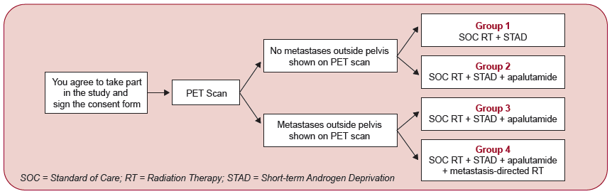
- After you finish your study treatment, your doctor will continue to follow your condition.
  - You will be seen approximately once every 3 months for the first 2 years, then once every 6 months during the following 3 years. For the remaining years of follow-up, you will be seen annually.

Who will take part in this study?
- Approximately 804 men will participate in EA8191/INDICATE.
- Participants must be at least 18 years old, with evidence of biochemical recurrence (a rise in the blood level of prostate-specific antigen [PSA]) after radical prostatectomy, and no evidence of metastases on conventional imaging.
- You can decide to stop taking part in EA8191/INDICATE at any time, even after you have enrolled.
What are the costs of taking part in this study?
- Just as you would if you were getting the usual care for your cancer, you and/or your insurance plan will need to pay for some or all of the costs of medical care you get as part of this study. Check with your insurance company to find out what they will pay for.
- You/your insurance provider will NOT have to pay for the apalutamide (if you are in Group 2, 3, or 4) or the second PET scan, if received (if you are in Group 3 or 4).

How can you learn more or sign up for the trial?
- About the EA8191/INDICATE study, talk with your doctor, or:
  - Visit https://ecog-acrin.org/clinical-trials/ea8191-indicate-prostate-cancer/
    - For information about the locations where the study is available, scroll down the page to Locations and Contacts and click the + sign.
  - Call the NCI Cancer Information Service at 1-800-4-CANCER (1-800-422-6237)
- About clinical trials:
  - General cancer information: visit the NCI website at www.cancer.gov
  - Insurance coverage: visit www.cancer.gov/clinicaltrials/learningabout/payingfor
- About ECOG-ACRIN:
  - Visit www.ecog-acrin.org
  - For a list of patient resources and links to patient advocacy groups, visit https://ecog-acrin.org/patients/resources
Social Media Messaging
Twitter | Facebook/LinkedIn
Do you have #ProstateCancer that has returned after prostatectomy? If so, you may be able to participate in this study of potential new treatment approaches. Learn more about the EA8191/INDICATE study: http://bit.ly/indicate-trial #pcsm #ProstateCancerAware | Do you have prostate cancer that has returned after prostatectomy? If so, you may be able to participate in this study of potential new treatment approaches. Learn more about the EA8191/INDICATE study: http://bit.ly/indicate-trial
Learn about the EA8191/INDICATE study, treating #ProstateCancer that has come back after surgery with apalutamide and targeted radiation based on PET imaging. More information: http://bit.ly/indicate-trial #pcsm | Learn about the EA8191/INDICATE study, treating prostate cancer that has come back after surgery with apalutamide and targeted radiation based on PET imaging. More information: http://bit.ly/indicate-trial
You may be eligible to participate in a #prostatecancer study, EA8191/INDICATE, for patients with post-prostatectomy recurrence. Learn more: http://bit.ly/indicate-trial #pcsm #ProstateCancerAware | You may be eligible to participate in a prostate cancer study, EA8191/INDICATE, for patients with post-prostatectomy recurrence. Learn more: http://bit.ly/indicate-trial

Hashtags: #ProstateCancer #pcsm #ProstateCancerAware
Sample Imagery
